The ARS New York District 65th Convention & Rose Show
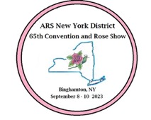
Hosted by Long Island Rose Society & Manhattan Rose Society
“A Confluence of Roses”
September 8-10, 2023
DoubleTree by Hilton Binghamton,
225 Water Street, Binghamton, NY 13901
Dedicated to Louise Coleman

con·flu·ence: a coming or flowing together, meeting, or gathering at one point.
Our Convention theme this year reflects connections as
Rosarians, their roses and two rivers all meet to form confluences at the
2023 ARS New York District 65th Convention.

Your registration fee includes: Friday Night Welcome Buffet Dinner, Saturday Continental Breakfast, Saturday Lunch and Saturday Evening Awards Banquet (plated dinner), the Rose Show and Friday & Saturday programs!
There will be a cash bar on Friday and Saturday evenings.
Sunday Morning Breakfast/NY District Meeting is optional
Friday the events begin with a Photography Workshop presented by Dr. Curtis Aumiller, Immediate Past ARS National Photography Chair. The workshop will focus on how you can take great rose photos with your camera or iPhone/Android. Curtis will share tips on taking award winning photos.

Friday Evening features our Welcome Buffet Dinner and later that evening – Rose Show set up.

Saturday features the Rose Show, Rose Show Awards and afternoon programs:
- Mike Shoup, The Antique Rose Emporium, presenting: “Schooled by an Old Rose” – Breeding Advances, Gardening Nuances & cultural issues pertinent today.
- Dr. David Byrne, Texas A&M Professor, Rosa and Prunus Breeding and Genetics. Basye Chair of Roses Genetics. Presenting: “The Beauty and the Beasts: the journey towards RRD and black spot resistant roses for the garden” – The ongoing research to develop sustainable rose cultivars for the industry.
There will be a Silent Auction and Raffle Baskets offered.

Saturday Evening - The Awards Banquet! – presenting the District Rose Show Trophies and District Awards. ARS Vice President, Craig Dorschel and WFRS Vice President for North America, Robert Ardini will speak at banquet.

Sunday Morning – The District Meeting and Breakfast will take place as our final event of the weekend.

Binghamton - Surrounded by lovely hills and centrally located, Binghamton features the confluence of the Chenango and Susquehanna rivers and is known as the Carousel Capital of the World. There are also many other wonderful places to visit while you are here:
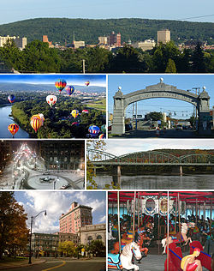
Clockwise from top: Binghamton skyline, the Endicott Johnson Square Deal Arch, the South Washington Street Bridge, the Ross Park Zoo carousel, Court Street Historic District, downtown in winter, and the Spiedie Fest and Balloon Rally.

The Roberson Museum and Science Center, in the heart of Binghamton, is home to the Binghamton Visitor's Center, the Link Planetarium, and a number of exhibits detailing the culture and history of Greater Binghamton and the Southern Tier.
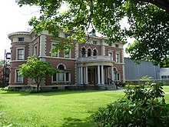

Robertson Museum & Science Center

The Kopernik Observatory & Science Center observatory is the largest public observatory in the northeast United States. The Binghamton Zoo at Ross Park, in the Southside, opened in 1875 and is the fifth-oldest zoo in the nation.
Binghamton is known as the Carousel Capital of the World, as it houses six of the remaining antique carousels. Two are within city limits, one at Recreation Park and another at the Binghamton Zoo at Ross Park. Other visitor attractions include the Phelps Mansion museum, the Cutler Botanic Garden, the Bundy Museum of History and Art, and the interactive, child-oriented Discovery Center.
Cutler Botanic Garden - The Cutler Botanic Garden is a center for teaching horticulture and environmental issues. The garden encourages an appreciation of the environment and helps teach the value of natural resources through educational activities. The purpose is to help participants teach themselves to grow plants with minimal negative effect on the environment. 13 themed areas are represented in Cutler Botanic Garden: Propagation, Hemerocallis, Composting and Rain barrel demonstration, Shade Garden, Perennials, Heath & Heathers, Rock Garden, Native Habitats, Ornamental Grasses, Herbs, Roses and Vegetable Garden along with several annual flower beds.

Cutler Botanic Garden is one of approximately 360 gardens in the United States designated as a display garden of All-America Selections. Each year, Cutler Botanic Garden staff previews the AAS winners that will be available commercially the following year. The AAS is a non-profit, educational organization for evaluating new varieties from around the world.

The community uses the garden for a variety of activities. It provides an outdoor classroom where local students are introduced to the plant kingdom. Adult classes in subjects such as annuals, perennials, roses, Integrated Pest Management, and composting include hands-on workshops in the garden. Cutler Botanic Garden is free and open to the public year-round from dawn to dusk for self-guided tours.
https://ccebroomecounty.com/gardening/cutler-botanic-gardens

